Published in Scientia Danica. Series H, Humanistica, 4 · vol. 7, Det kongelige danske videnskabernes selskab
2016

Abstract
Based on data gathered from church records in two Swedish counties, this study shows that it is possible to conduct relatively detailed spatial analyses of epidemics in the 18th century. The outbreak of two diseases, smallpox (1751-52) and dysentery (1772-73), are in focus. They differ in several ways (e.g. various microbes transmitted in different ways), as did the counties (e.g. population density, topography), but nonetheless there is a striking similarity between the outbreaks. Long, low intensity initial phases with a few local epidemics were followed by an intensive diffusion phase where the diseases gained an epidemic character in a few weeks. In both counties the diffusion pattern was irregular with epidemics in parishes located far apart. Their spread was moderated in the winter but then had a renewed impetus in their second year. In several cases the infection spread to neighbouring parishes from those affected early on. Still, we can barely see any obvious traces of epidemic “roads” or “waves”. One reason for the irregular patterns is probably that the diseases are mapped out through mortality instead of morbidity. But it may also be that this, albeit roughly, is actually the main pattern of early modern epidemic diffusion. The assumption of expected epidemic “roads” or “waves” may be incorrect. People interacted more, and moved over greater distances than one readily believes. [abstract]

Daniel Larsson
Ph.D., researcher, teacher
Department of Historical Studies
Box 200, 405 30 Gothenburg

daniel.larsson@history.gu.se
A Landscape of Early Modern Mortality [heading 1]

Spatial Perspectives and Methodological Thoughts on 18th Century Diseases [heading 2]

When the British physician John Snow plotted the cholera victims in the area surrounding London’s Broad Street in in the early 1850s, he was not breaking new ground. Attempts to spatially identify epidemics had been made for decades, but gained both speed and attention during the cholera epidemics of the 19th century. Snow’s map garnered a great deal of attention later, however, and today it often features in lectures as an early example of a spatial analysis created with the aim of revealing the elusive causes of diseases.
Mapping became a common way to describe and analyse epidemics, especially in the 19th and 20th centuries. In terms of the 17th and 18th centuries, however, the spatial interest in crises and epidemics only created limited interest among the historians, not least in Scandinavia. This is something of a paradox as supply crises and infectious diseases on a Western European level in the early 19th century sharply affected the mortality levels of these countries.

This article is based on pilot studies in a larger ongoing project. The aim is to draw some primary conclusions on diffusion patterns for two of the early modern era’s most severe diseases while discussing empirical challenges and methodological issues related to spatial compilations of diseases in the 18th century’s demographic regime.
Are there reasons to talk about the “waves” and “roads” that are so often brought up when it comes to epidemics? The very word “epidemic” implies speed, and one can easily imagine how pestilence swept between villages and cities. But how quickly did they spread? In the following we will tackle two classic infectious diseases from the 18th century, bacterial Dysentery and the notorious viral disease Smallpox, but first some methodological decision making must be covered. [Body]

Dusty church records and digital tools: Some methodological issues [heading 2]

Firstly, there are no simple ways to conduct spatial compilations of 18th century epidemics. A major difficulty is the scarce availability of sources and statistics, and a first withdrawal must be made when considering what we actually want to measure. Disease diffusion is contamination and should ideally be studied via its morbidity, but such data from the 18th century is very unusual, and therefore the disease specific mortality must become a proxy. The next problem concerns the balance between time and space. Despite not being able to use morbidity as an instrument, it is clearly possible to make maps that annually follow, for example, the 18th century plague or the rumbling ways of 19th century cholera over various parts of the world. For Sweden and Finland it is also possible to use a rather unique source material, the early national statistics, “Tabellverket”, which were already being kept in 1749 and provide information on population, births, marriages, number of households, deaths and causes of death, etc., both annually and at a parish level. This, and later corresponding materials in other countries, makes it possible to study a range of demographic variables over long time spans with a relatively high spatial accuracy. But if we will study an epidemic’s diffusion closer to the ground – in order to reveal connections to human behaviour in further detail – then things become far more complicated. Maps based on annually summarised disease mortality data can provide good information about distribution and regional differences, but they do not tell us how quickly diseases spread or which pattern the diffusion had. Thus, it is essential to break down the year into smaller longitudinal units. In doing so we must leave the excellent national statistics and collect the data from ecclesiastical burial records where the dates of the epidemic victims’ deaths were written down. [Body]

Figure 1. Typical church record, Sillerud parish, Värmland County, Sweden, 1772 [heading 4]

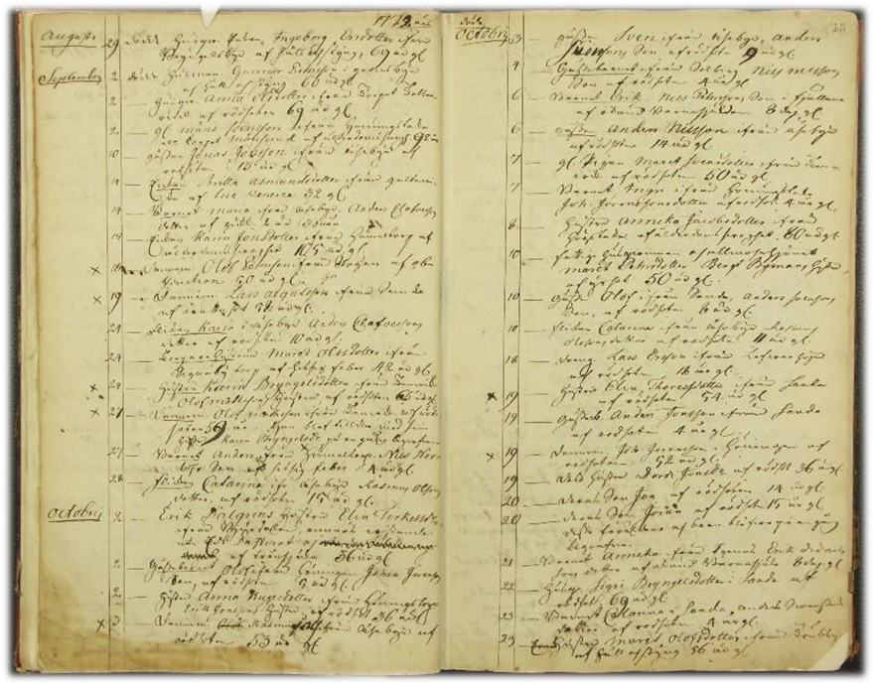

The Swedish church records are, although photographed, not digitized. Compared to using the national statistics, the labour required to obtain data thereby increased significantly and greatly limited the area we wanted to map; it would have been easy to end up with a study limited to a single parish. However, as the aim was to compile and analyse the geographical pattern of epidemic movements this level has proven to be somewhat problematic. The villages and individual data on residency in the burial records must be transcribed and positioned in today’s landscape, a challenging and time-consuming process which can be misleading due to biases created by the gap between actual morbidity and our measured mortality. A larger area, however, can reduce the problem of “the morbidity-mortality gap” and give a more reliable picture of contamination patterns. In this study the mapping has therefore been made at the county parish level where the dates for epidemics were collected from burial records, parish by parish, in two different counties. [Body]

Disease diffusion at the local level in the 1770’s and 1750’s [heading 2]

Dysentery, Värmland, 1772-73 [heading 3]

During the severe mortality crisis in the early 1770s, Sweden was hit by brutal outbreaks of dysentery. The crisis, which was basically a supply crisis due to crop failures that affected much of Northern Europe, led to hard restrictions on trade in cereals, not least from the German ports. As epidemics broke out the mortality rose, and the import dependent and politically troubled Sweden of 1772 was particularly exposed in comparison to the rest of Europe. The governmental remedial measures entered too late; in 1773 the mortality rate rose to 52 pro mille for the country as a whole, roughly double the normal level. With the exception of the plague in 1710-11, it was the highest level recorded in Sweden during the 17th, 18th and 19th centuries.
An area that was particularly hard hit was the county of Värmland. It is located along the border to Norway in western Sweden and has an area of about 17,500 km² (about 160 kilometres on the east–west axis). The population density was mainly low, in 1810 there were only 8 people per km² of land, with scattered villages and farms throughout wide, hilly forest areas. The dysentery was – although somewhat forgotten in modern overall disease historical handbooks – one of the truly great infectious diseases in Scandinavia before the 20th century. The lethal epidemics were caused by bacteria (Shigella dysenteriae. There was also an amoeba variant, but it was much less terminal). The incubation period ranges from one day up to a week. Infected humans got a stomach ache, fever and bloody stools. The bacteria spread via feces, water and food, but could also infect directly. It usually broke out in late summer and early autumn. The bacterium does not last long outside the human body, but unlike e.g. bacterial cholera, small doses are sufficient to cause symptoms of infection, and the carrier could infect long after recovery.

The dysentery in Värmland initially spread slowly, starting with a few, low intensity local epidemics in the southern part of the county in February. They went on without any further diffusion until May, when a small number of other parishes were hit. A far more intense epidemic phase started in August. In a few late summer and early autumn weeks the number of parishes with registered dysentery deaths increased from a handful to c. 30. The peak of dispersion took place in November.
The intensive diffusion in the late summer of 1772 established dysentery in several locations in the county, but the epidemic weakened during the winter months after its peak in November. In the second intense phase in August 1773 it seems that the disease mainly spread to parishes neighbouring those who were hit the year before. But what about the intensive phases? A closer look at the late summer of 1772 shows that the spread was quite asymmetric. Map no. 1 illustrates the order of affected parishes in August and September 1772 (no. 1 is the first week of August, no. 2 the second week and so on). It is difficult to see any pattern at all, except for a tendency towards epicentres in the central and southeast areas of the county. [Body]

Map 1. The weekly order of dysentery outbreaks during the intense phase in August and September 1772, parish level, Värmland County, Sweden [heading 4]

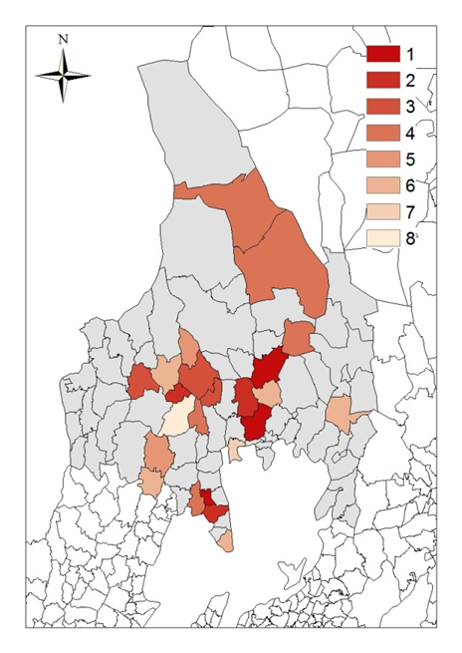
When the outbreak died out in the late autumn of 1773, it did so with a few lasting local epidemics in parishes which were located far from each other. [Body]

Smallpox, Skaraborg County, Sweden, 1751-52 [heading 3]

Finally, an outbreak of smallpox in the early 1750s is mapped out. The area covered is Skaraborg, a county located just southeast of Värmland between Sweden’s two largest lakes, Vänern and Vättern. The county’s northern and eastern parts are characterized by mixed terrain with considerable densely wooded areas. The central and southern parts are marked by plain areas with large and populous villages. The county’s area amounted to a little more than 8000 km² of land (ranging on the east-west axis between about 100 kilometres in the south, and 20–70 kilometres in the north), with a population density of c. 17 persons per km² land in 1810. Smallpox causes a characteristic rash and raised fluid-filled blisters in later stages. People were familiar with the disease because it had been around for hundreds of years and there were quite regular outbreaks; an average Swedish parish in the 18th century had to deal with smallpox every fifth to seventh year. Smallpox affected mainly young children as they had generally not been exposed to the virus in the past and thus had no immunity. The virus is mainly transmitted from person to person and does not last long outside the human body. It could, however, be spread in the air to the immediate environment and was therefore a distinct epidemic disease that needed previously unaffected human hosts. The incubation period was one to two weeks, with the disease only becoming transmissible after its onset.

The epidemic started with an outbreak in a few parishes in the southwest part of the county in January 1751. The spread – or, more accurately, the outbreaks in various locations throughout the county – slowly took place throughout 1751. The epidemic then continued with a slight slowdown over the winter, and reached a more intense diffusion in January, February and March with its culmination in the spring of 1752.
In the intensive phase in January and February the disease spread in different directions from parishes in different parts of the county. More parishes were affected in the county’s mixed landscape in the north and east than in the densely inhabited central and southern plain areas, but on map 2 (where no. 1 corresponds to the first week of January, no. 2 the second week and so on until no. 8, the last week of February), there is no single core area or main direction for the contagion, there are several. [Body]

Map 2. The weekly order of smallpox outbreaks during the intense phase in January and February 1752, parish level, Skaraborg County, Sweden [heading 4]

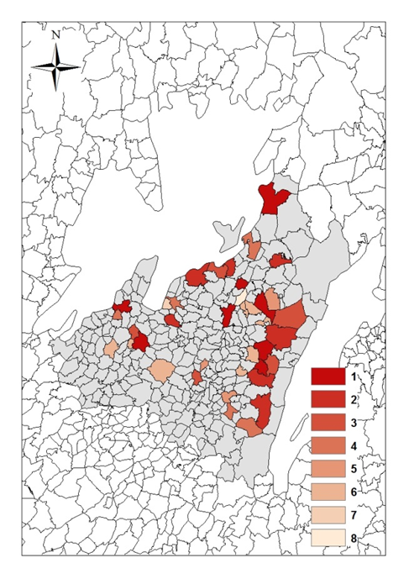

Several of the parishes with smallpox during week no. 1 of the epidemic, however, are the same as the year before and in several cases it was their neighbours, or neighbours’ neighbours who were affected.
The initial phase of the smallpox epidemic in Skaraborg was similar to dysentery in Värmland. It was slow, but at a certain stage - in this case in January and February 1752, it was followed by a more intense diffusion when the number of affected parishes rapidly grew from about 10 to 36. Thus, the geographical culmination was also late in Skaraborg, over a year from the first outbreaks. When the epidemic faded out in the late autumn of 1752 it did it with the same pattern as the dysentery: ongoing local outbreaks far from each other. [Body]

Summary [Heading 2]

Spatial descriptions and compilations tend to generate more questions than they answer, not least when dealing with conditions 250 years ago. The lack of good maps, sometimes ambiguous and rough ecclesiastical records and time-consuming data collection sharply reduce the possibilities. In this pilot study, diffusion patterns of two of history’s most severe infectious diseases, smallpox and dysentery, have been in focus. A number of methodological problems have come to light enabling conclusions to be drawn from them. Finding a balance between time and space is vital. The earliest national statistics at a parish level are from the mid-1700s (Sweden), but are summarised annually. A prerequisite for studying epidemic geographical movements more precisely however – underlined by the smallpox and dysentery’s intensive dissemination in the winter of 1751-52 and late summer of 1772 respectively – is a more sufficient time subdivision, and data therefore has to be gathered from church records forcing us to analyse smaller areas than desired, normally villages or single parishes. Thus, a main point of this study was to expand the area to a county level, and at least tentatively determine what knowledge could be gained from this.
The similarity between the outbreaks of dysentery and smallpox in this study is remarkable. The two diseases are caused by various microbes, which are transmitted in different ways resulting in different symptoms and generally affecting different age groups. The two counties in focus were also quite diverse – not geographically, but in terms of population density, the actual supply situation, village structure and topography. Although there are huge gaps in the preserved church records from Skaraborg in 1751 (35 parishes with smallpox had to be removed) the epidemics in both Värmland and Skaraborg had long, low intensity initial phases with a few local epidemics that were followed by an intensive diffusion phase where the diseases – expressed by disease mortality – gained an epidemic character in one or two months. In both cases the spread was somewhat moderated in the winter but had a renewed impetus in their second year (smallpox in January and February, and dysentery in late summer).
The diffusion pattern was irregular with epidemics in parishes located far apart in Skaraborg as well as in Värmland. In several cases the infection later spread to neighbouring parishes from those affected early on. Still, we can barely see any obvious traces of epidemic “roads” or “waves”. Missing church records are probably not the answer to this. One important reason is probably that we have mapped out the disease distribution through mortality, and not through morbidity, meaning that the “mortality–morbidity gap” also affects compilations at the county level. Another interpretation to the irregular patterns may also be that we, albeit roughly, are actually seeing the main patterns of early modern epidemic diffusion. The counties studied cover large areas of land and, additionally, the assumption of expected “waves” or “roads” may be incorrect. People were moving more and over greater distances than one readily believes. In the burial records we find numerous examples of how people on the move spread diseases. So next to structural factors such as the supply situation, population density and the longitudinal distance to previous epidemics (smallpox), it’s likely that patterns of movement and a series of factors that are hard to recognise in the source material played an important role in the epidemic’s outbreaks and diffusion: which and how many people did travellers met along the way? What type of contact took place? Which stage of the disease did you or the people you met have? And how far had you planned to go? A week long incubation period may have allowed sick people – although feeling quite well – to move relatively far, crossing perhaps three or four parishes, at least, before they became ill or developed symptoms.

The study has identified a number of conditions that are both necessary and possible to investigate further. How does the mortality curve for each epidemic match the diffusion curve in a weekly or monthly perspective? Can we find the longitudinal character of the outbreaks by looking at e.g. the smallpox epidemic that we know took place in Värmland in 1772-73, or the dysentery epidemic which broke out in Skaraborg in 1772? And what about the length of the epidemics and the correlation with population size and population density? Some parishes had epidemic mortality for several months, others not. What did these severely or moderately affected parishes have in common? And moreover, is it right to define the long, low intensive periods prior to the actual epidemic explosions as “starting phases”? Much seems to indicate that it was just normal conditions; both the smallpox virus and the shigella dysenteriae seem to have been present every year not only in the country as a whole, but also down to the (normal sized south or middle Swedish) county level. [Body]

Diagram 1. The number of affected parishes (Y–axis) per month (X–axis) during the dysentery epidemic in Värmland County 1772-73 and the smallpox epidemic in Skaraborg County 1751-52 [heading 4]

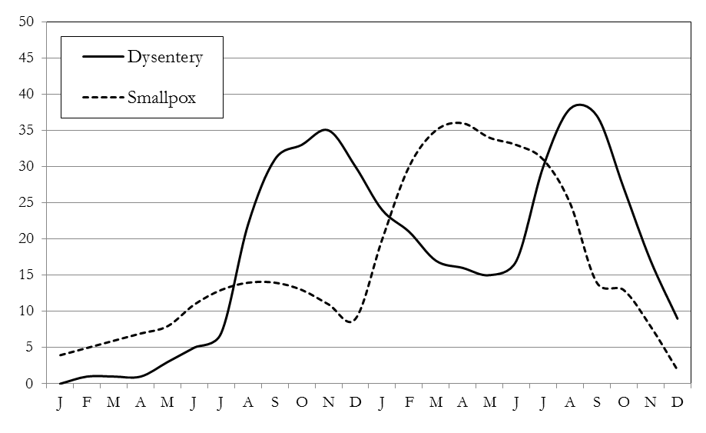

When it comes to cholera we have identified both its worldwide pandemics as branched epidemic routes in different countries. But when it comes to the other great scourges, like typhoid, dysentery and smallpox, we have much left to explore. The problems are many and several questions must be left unanswered, but there is much to gain from further attempts. [Body]

Bibliography [Heading 2]

Castenbrandt, H, Rödsot i Sverige 1750-1900. En sjukdoms demografiska och medicinska historia, diss., University of Gothenburg 2012

Cliff, A, Haggett, P, Smallman-Raynor, M, World Atlas of Epidemic Diseases, Taylor and Francis Dewey, 2004

Crosby, A W, “Smallpox”, Chapt. VIII, The Cambridge World History of Human Diseases, Cambridge University Press, 1993

Devereux, S, Theories of Famine, Harvester Wheatsheaf, 1993

Jutikkala, E, ” Spridningsmönstren hos smittkopporna under andra hälften av 1700-talet i Finland”, Festskrift til Kristof Glamann, 1983

Koch, T, Cartographies of Diseases. Maps, Mapping, and Medicine, Redlands, Calif., ESRI press, 2005

Larsson, D, Den dolda transitionen. Om ett demografiskt brytningsskede i det tidiga 1700-talets Sverige, diss., University of Gothenburg, 2006

Niyogi, S, “Shigellosis”, Journal of Microbiology, 2005, 43(2)

Palm, L A, Livet, kärleken och döden fyra uppsatser om svensk befolkningsutveckling 1300-1850, Göteborg, 2001

Persson, E B, Pestens gåta. Farsoter i det tidiga 1700-talets Skåne, diss., University of Lund, 2001

Post, J D, “The Mortality Crises of the Early 1770s and European Demographic Trends”, The Journal of Interdisciplinary History, Vol. XXI:I, 1990

Sarracino, F, Explaining Famines: A Critical Review of Main Approaches and Further Causal Factors, paper, NAF. International Working Paper Series no. 10/02, 2010

SCB, Statistisk årsbok, 1923 and, 1969

Sköld, P, The Two Faces of Smallpox. A Disease and its Prevention in Eighteenth- and Nineteenth-Century Sweden, diss., University of Umeå, 1996

–, Kunskap och kontroll. Den svenska befolkningsstatistikens historia, University of Umeå, 2001

Wilson, J L, “Mapping the Geographical Diffusion of a Finnish Smallpox Epidemic from Historical Population Records”, The Professional Geographer, Vol. 45, Issue 3, 1993 [bibliography]

Cliff, A, Haggett, P, Smallman-Raynor, M, World Atlas of Epidemic Diseases, 2004, p. 11: Koch, T, Cartographies of Diseases. Maps, Mapping, and Medicine, 2005, ch. 2.
The research on crises has many components and specializations – i.e. demography, climate, diseases, and politics – and has become difficult to overview. New approaches have been needed for a long time (Devereux, S, Theories of Famine, 1993, p. 29; Sarracino, F, Explaining Famines: A Critical Review of Main Approaches and Further Causal Factors, 2010, pp. 2), not least research that reaches over and diminishes the boundaries between different disciplines. Spatial studies is one method, but when it comes to the early modern era the efforts have only just begun (in Scandinavia i.e. Jutikkala, E, “Spridningsmönstren hos smittkopporna under andra hälften av 1700-talet i Finland”, Festskrift til Kristof Glamann, 1983: Sköld, P, The Two Faces of Smallpox. A Disease and its Prevention in Eighteenth- and Nineteenth-Century Sweden, 1996: Castenbrandt, H, Rödsot i Sverige 1750-1900. En sjukdoms demografiska och medicinska historia, 2012). The present article emerges from pilot studies carried out in After the Wars, a project dealing with the 18th century Swedish mortality crises, which is funded by the Swedish Research Council.
Several examples in Koch 2005.
The data from Tabellverket is digitized and accessible at the Demographic Database, University of Umeå (http://www.ddb.umu.se/databaser/tabellverksdatabas/), 2014-12-23. A good overview of the Tabellverket and its stumbling initial years in Sköld, P, Kunskap och kontroll. Den svenska befolkningsstatistikens historia, 2001. Peter Sköld, historian at the Umeå universitet, also studied smallpox in his doctoral thesis, The Two Faces of Smallpox, 1996. When it comes to the geographical implications of smallpox, Sköld draws important conclusions about regional differences in many aspects on country and county level, but the patterns of diffusion at a local level are only sparsely examined (see chapt. III.6 and the example of Uppsala county).
At the parish village level there are of course other fine possibilities to draw conclusions from, e.g., the risk of infection through interaction in the local community (e.g., via kinship, baptisms, funerals, households etc.). A good example in Persson, E B, Pestens gåta. Farsoter i det tidiga 1700-talets Skåne, 2001, ch. 10.
The burial records usually tell us where people lived, not where they were when they died. We must expect a rather significant (spatial contamination) impact from the individuals who were sick but didn’t die at the parish village level. A majority of those who died during epidemics certainly died in their homes, not least children, but many did not. There are numerous examples in the burial records of people that where found “dead, lying beside the road to …”, or “was found in the woods …” especially during times of starvation and epidemics. James Wilsons study of smallpox in Isokyrö parish, Finland, 1822, shows the problems related to the use of mortality as a proxy for morbidity, see “Mapping the Geographical Diffusion of a Finnish Smallpox Epidemic from Historical Population Records”, The Professional Geographer, 1993, pp. 276-286.
“At micro scales of analysis, mapped mortality should not be used as a surrogate for tracking the geographical movement of epidemics. When broader scales are used, mortality may be satisfactory for plotting spatial trends in the epidemic diffusion process.” Wilson 1993, p. 285.
Cf. mortality levels in Palm, L A, Livet, kärleken och döden fyra uppsatser om svensk befolkningsutveckling 1300-1850, 2001. Norway was also badly affected, while Denmark didn’t see any sharp increase in mortality, probably thanks to distribution of grain and controlling and restricting people’s mobility, Post, J D, “The Mortality Crises of the Early 1770s and European Demographic Trends”, Journal of Interdisciplinary History, 1990, 49 pp.
SCB, 1923, Tab. 1, and 1969, Tab. 11.
Castenbrandt 2012.
Niyogi, S, “Shigellosis”, Journal of Microbiology, 2005, pp. 133–143: Castenbrandt 2012, 15 pp.
According to Tabellverket, Värmland County contained of 52 parishes at the time. In 1772 there is information about dysentery in 43 of them, 38 of which have contributed data to the maps here (5 parishes just had one or two dysentery victims or are missing information due to shortfalls, absence of notes on cause of deaths or because they have joint church records with other parishes). 1773 corresponds to figures 50, 41 (and 9).
SCB, 1923, Tab. 1, and 1969, Tab. 11.
Larsson, D, Den dolda transitionen. Om ett demografiskt brytningsskede i det tidiga 1700-talets Sverige, 2006, p. 103.
Crosby, A W, “Smallpox”, The Cambridge World History of Human Diseases, 1993, p. 1009. Sköld 1996 is also a well-known study of smallpox in Sweden.
According to Tabellverket, Skaraborg County contained 157 parishes at the time. In 1751 there is information about smallpox in 64 of them, but only 29 have contributed data to the maps (data from 35 parishes is missing, mainly due to a widespread use of joint church books at the time, and fewer due to shortfalls, cf. note 12. 1752 the corresponding figures are 128 and 66 (and 62).
During the cholera epidemic in 1834 we know several examples of rapid diffusion due to people’s movements, see also a number of good, earlier examples from southern Sweden in Persson 2001, pp. 135-37.
A quick glance in the national statistics Tabellverket tells us that smallpox was also present in Skaraborg in the years surrounding 1751-52, and that dysentery was in Värmland in the years prior to 1772-73 and 1775 (1774 is missing in the records), although not with a mortality rate on a magnitude similar to that of 1772-73.
Not least do the international Early modern epidemic diffusion patterns need to be examined, e.g. on the Scandinavian Peninsula and the countries around the Baltic Sea.

