Association between excessive BMI increase during puberty and risk of adult cardiovascular mortality in men: a population-based cohort study
Prof Claes Ohlsson¹, Maria Bygdell Pharm D¹, Arvid Sondén MSc², Prof Annika Rosengren³, Jenny M Kindblom PhD¹

¹Centre for Bone and Arthritis Research, Institute of Medicine, the Sahlgrenska Academy, University of Gothenburg, Gothenburg, Sweden
²Bioinformatics Core Facility, the Sahlgrenska Academy, University of Gothenburg, Gothenburg, Sweden
³Department of Molecular and Clinical Medicine, the Sahlgrenska Academy, University of Gothenburg, Gothenburg, Sweden

Corresponding authors: Jenny M Kindblom, MD, PhD, Klinfarmlab, Vita Stråket 11, Sahlgrenska University Hospital, S-413 45 Gothenburg, Sweden, Jenny.kindblom@gu.se, +46 709 902201, and Claes Ohlsson, MD, PhD, Klinfarmlab, Vita Straket 11, Sahlgrenska University Hospital, S-413 45 Gothenburg, Sweden, claes.ohlsson@medic.gu.se, +46 706 832966.

Abstract
Background
Overweight during childhood and adolescence is associated with increased risk of adult cardiovascular disease (CVD) but the relative contribution of pre-pubertal childhood BMI and BMI change during puberty for adult CVD mortality is unknown. We, herein, evaluated the contribution of these two distinct developmental BMI parameters for adult CVD mortality in men.

Methods
In this population-based study in Gothenburg, Sweden, men born 1945-1961 with information on both childhood BMI at age 8 and BMI change during puberty (BMI at age 20 - BMI at age 8) were followed until December 2013 (n= 37,672). BMI was collected from pediatric growth charts and mandatory military conscription tests. Information on mortality was retrieved from high quality national registers (3,188 deaths, 710 CVD deaths).

Findings
The correlation between childhood BMI and BMI change during puberty was marginal (r=0·06). BMI change during puberty, but not childhood BMI, independently associated with adult all-cause and CVD mortality. Both boys developing overweight during puberty (HR 2·39; 95% CI 1·86-3·09) and boys who were overweight consistently throughout childhood/puberty (HR 1·85; 95% CI 1·28-2·67), but not boys with childhood overweight that normalized during puberty (HR=0·99, 95% CI 0·65-1·50) had increased risk of CVD mortality compared with boys without childhood or young adult overweight. The association between BMI change during puberty and CVD mortality was non-linear with a substantial association above a threshold of 6·7 units increase in BMI.

Interpretation
Excessive BMI increase during puberty is a risk marker of adult CVD mortality.

Funding
This study was supported by the Swedish Research Council and by grants from the Swedish government (under the Avtal om Läkarutbildning och Medicinsk Forskning [Agreement for Medical Education and Research]), the Lundberg Foundation, the Torsten Söderberg Foundation, the Novo Nordisk Foundation and the Knut and Alice Wallenberg Foundation.

Introduction
According to the World Health Organization, more than 1·9 billion adults were overweight in 2014 and of these, over 600 million were obese (1). In 2010, overweight was estimated to account for 3·4 million deaths globally, mainly due to increased risk of cardiovascular mortality (2). There are concerns that a sustained obesity epidemic may offset recent advances in medicine and result in a decline in life expectancy (3).
Not only adult obesity but also childhood obesity is a major health concern (4). Several studies have shown an association between obesity during childhood or adolescence and adult risk of cardiovascular (CVD) events (5-10). Interestingly, when evaluated in a large cohort of Israeli army personnel, elevated BMI in late adolescence was associated with coronary heart disease, independently of adult BMI (9). This finding supports previous data from the Harvard Growth Study, which also showed that the relation between adolescent overweight and increased adult incidence of coronary heart disease was independent of adult BMI (8). The independent association between childhood BMI and adult CVD morbidity is controversial. A study by Juonala et al revealed a clear increased risk of cardiometabolic disease for individuals with overweight in adulthood while no independent increased risk was observed for individuals with childhood overweight (11). Mortality was not an included endpoint in that study.
Some studies have been adequately powered to evaluate the association between childhood or adolescent BMI and adult CVD mortality (6, 9, 10). A recent large scale study of Israeli subjects demonstrated that not only overweight but also a BMI within the acceptable normal range during late adolescence was associated with increased adult CVD mortality (10). There is also evidence of an association between high childhood BMI and an increased risk of adult CVD death (7).
Collectively, there are several studies reporting that high childhood BMI or high adolescence BMI associates with increased risk of adult cardio-metabolic syndrome and/or CVD death (5-10, 12, 13). However, the relative contribution of high BMI during childhood before puberty and of BMI increase during puberty for the risk of adult CVD mortality is largely unknown (14, 15). To evaluate the relative contribution of these two distinct developmental BMI parameters for the risk of adult CVD mortality, information on both childhood BMI before pubertal onset and BMI shortly after puberty at young adult age is required. As a part of the ongoing population-based BMI Epidemiology STudy (BEST) in Gothenburg, Sweden, we collected information on childhood BMI and young adult BMI shortly after puberty for men born 1945-1961. The unique Swedish personal identity number (PIN) was linked to high quality Swedish national registers which enabled us to determine the relative contribution of childhood BMI and BMI change during puberty for adult CVD mortality in 37,672 men with virtually no loss to follow-up. Based on our previous finding that BMI increase during puberty, but not pre-pubertal childhood BMI, associates with the amount of the cardio-metabolically harmful visceral fat in young adult men (16), we, herein, hypothesized that BMI increase during puberty might be an independent risk marker of adult CVD mortality.

Methods

Study Population
We have collected birthweight as well as directly measured height, and weight from centrally archived School Health Care (SHC) records for all men born 1945 to 1961 in Gothenburg, Sweden (see also Supplementary Methods). We also collected height and weight at young adult age from mandatory military conscription tests. Conscription was mandatory until 2008 for all Swedish men. The study cohort was linked to high quality national disease registers using the PINs from the included subjects. Eligible individuals were those with a SHC record in the central archive, and a 10-digit PIN (Figure S1). Subjects with data available for calculation of both childhood BMI and young adult BMI were included in the present study (n=37,672; Table 1 and Figure S1).
This study was approved by the ethics committee of the University of Gothenburg, Sweden. There was no commercial sponsorship.

Exposures
Pre-pubertal childhood BMI and young adult BMI were calculated using all paired height and weight measurements in the period between 6·5 and 9·5 years of age for pre-pubertal childhood BMI, and in the period 17·5 to 22 years of age for young adult BMI, and age-adjusted using linear regression models to 8 and 20 years of age, respectively. BMI change during puberty was defined as the difference between young adult BMI and childhood BMI. Childhood overweight (≥17·9 kg/m²) was defined according to the Centers for Disease Control and Prevention (CDC) cutoff´s at 8 years of age (17).

Outcomes
Linkage to registers held by the National Board of Health and Welfare and Statistics Sweden was performed using the individuals´ 10-digit PIN. The causes of death were coded according to the International Classification of Diseases (ICD) system. CVD mortality was defined as I00-I99 in ICD10, and as 390-459 in ICD 8 and 9 (18, 19). Subjects who died or emigrated before age 20 were excluded from the analysis (Figure S1). The men in the study were followed from 20 years of age until censoring due to death, migration or until 31st of December in 2013.

Statistical Analyses
We used Cox proportional hazard regression to analyze the association between exposures and mortality. Childhood BMI was log-transformed and standardized and BMI change during puberty was standardized when used in the Cox regression models. The assumption of proportionality was confirmed for all variables. Possible interactions were evaluated by addition of an interaction term in the linear Cox regression models, and p<0.05 for the interaction term was interpreted as a statistically significant interaction. The interaction term included the two parameters (continuous) of interest multiplied by each other.
BMI change during puberty as a quadratic term showed a statistically significant association with CVD mortality and therefore we also used a restricted cubic spline-approach in the Cox regression analysis for a flexible non-linear assessment of the hazard ratio (HR) in relation to BMI change during puberty (20). Five knots placed at the BMI change during puberty percentiles 10, 25, 50, 75 and 90 were found to give a small Akaike Information Criterion and capture the average curve shape over a systematic assessment of different alternatives. Kaplan-Meier survival plots, analyses using restricted cubic splines, and the test for proportionality were done in R (21) using the “survival” (22) and “rms” (23) packages . For all other statistical analyses SPSS version 22 was used.

Results

Study cohort
Cohort description is shown in Table 1. Although the correlation between childhood BMI and young adult BMI was substantial (r=0·61), the correlation between childhood BMI and BMI change during puberty was marginal (r = 0·06). As expected, the correlation between BMI change during puberty and adult BMI was also substantial (r=0.82). Mean follow-up starting from 20 years of age was 37·8 years (1,422,185 person-years follow-up). 3,188 all cause and 710 CVD deaths occurred before the end of follow-up (Table 1).

BMI change during puberty associates with all-cause mortality
In the Cox proportional hazards models adjusted for birth year and country of birth, BMI change during puberty (HR=1·05 per SD increase, 95% CI=1·02-1·09) but not childhood BMI, was directly associated with all-cause mortality when evaluated separately (Table 2). Similar results were seen when childhood BMI and BMI change during puberty were included together in the same model (Table 2). Inclusion of a quadratic term for BMI change during puberty in the Cox proportional hazard models revealed a non-linear association between BMI change during puberty and all-cause mortality (p<0·0001). This was further evaluated using a restricted cubic spline approach, which confirmed a non-linear association between BMI change during puberty and all-cause mortality (p<0·0001, Figure S2).

BMI change during puberty associates with CVD mortality in a non-linear manner
Next, the associations between childhood BMI and BMI change during puberty and adult CVD mortality were evaluated. In separate analyses, childhood BMI associated weakly while BMI change during puberty associated relatively strongly with adult CVD mortality (Table 2 and S1). In the combined analysis, only BMI change during puberty independently associated with CVD mortality (HR=1·21 per SD increase, 95% CI 1·13-1·30; Table 2). There was no statistically significant interaction between childhood BMI and BMI change during puberty for the association with CVD death (data not shown). Both boys developing overweight during puberty (HR 2·39; 95% CI 1·86-3·09) and boys who were overweight consistently throughout childhood/puberty (HR 1·85; 95% CI 1·28-2·67) had increased risk of CVD mortality compared with boys without childhood or young adult overweight (Table 3). In contrast, subjects that were overweight at 8 years of age and became normal weight during puberty did not have increased risk of adult CVD mortality compared with subjects with normal weight both at 8 years and at 20 years of age (HR=0·99, 95% CI 0·65-1·50; Table 3). Subjects who became overweight during puberty did not have statistically significantly increased risk of CVD mortality compared with boys overweight throughout childhood and puberty (HR=1.28, 95% CI 0.83-1.98). For the analyses described above (Table 3), overweight and obese subjects were pooled into one group referred to as overweight. Further sub-analyses of overweight and obese subjects separately revealed a similar pattern of associations (Table S2).
Inclusion of a quadratic term for BMI change during puberty in the Cox proportional hazard models revealed a non-linear association between BMI change during puberty and adult CVD mortality (p<0·0001). This was further evaluated using a restricted cubic spline approach, which confirmed a statistically significant non-linear association between BMI change during puberty and adult CVD mortality (p<0·0001 Figure 1A). The nonlinear association remained statistically significant after adjustment for childhood BMI (p=0·00017 Figure 1B). The optimal placement of knots in the restricted cubic splines analyses according to Akaike Information Criterion included a knot at the 75th percentile. From the appearance of the restricted cubic spline curve (Figure 1), the 75th percentile (corresponding to a BMI increase during puberty of 6.7 units) represents the cut-off from which the curve rises rapidly. For subjects in the upper quartile of BMI change during puberty, a substantial association between BMI change during puberty and CVD mortality was observed (HR 1·22 per unit increase in BMI change, 95% CI 1·15-1·29) while no significant association was found for subjects with a BMI change during puberty below this threshold (Q1-Q3; Figure 1). The importance of this threshold was further illustrated in a Kaplan-Meier survival plot, revealing increased adult CVD mortality in subjects with a BMI change during puberty above this threshold compared with subjects with a BMI change during puberty below this threshold (p=0·00037; Figure 2). Evaluation using cumulative incidence plots of cardiovascular mortality and non-cardiovascular mortality did not indicate that non-cardiovascular deaths would have influenced our finding of increased risk of CVD mortality for subjects with a high BMI increase during puberty (quartile 4) compared with subjects in quartiles 1-3 of BMI increase during puberty (Figure S3).
Less powered exploratory sub-analyses of CHD, Stroke, IS and ICH mortality separately revealed a similar pattern of general higher HRs for the association using BMI change during puberty than for the association using childhood BMI (Table S3).
As expected, young adult BMI was relatively strongly associated with CVD mortality (Table S4, Figures S4 and S5). Combined analysis including both BMI change during puberty and young adult BMI revealed that only BMI change during puberty independently associated with adult CVD mortality (Table S5) and evaluation using a restricted cubic spline approach revealed that this independent association was nonlinear (p<0·0001, Figure S6).

Sensitivity analysis
Exclusion of the first ten years of follow-up did not alter any of the described associations found in the present study, indicating that the results are not confounded by disease-related weight-loss (Tables 3 and S6). Similar results were also observed when the first 20 years (subjects only followed after 40 years of age, 2,239 censored; Tables 3 and S7) or 30 years (subjects only followed after 50 years of age, 3,626 censored; Tables 3 and S8) of follow-up were excluded. Conversely, an association between pubertal BMI change and adult CVD death was observed when only the first 30 years of follow-up were evaluated (HR=1·33, 95% CI 1·19-1·49 per SD increase in BMI change during puberty, Tables S9 and S10).
We also evaluated a subpopulation including boys born in Sweden and with parents born in Sweden. The described associations for BMI change during puberty with adult CVD mortality were very similar in this subpopulation of Swedish born boys (Tables S11-S12).
Adjustment for birthweight
Birthweight was available in a subsample of the present cohort (n=35,662). Additional adjustment for birthweight did not alter any of the described associations. This could be illustrated by that the association between BMI change during puberty and CVD mortality was similar before (HR per SD increase 1·22, 95% CI 1·14-1·31) and after (HR per SD increase 1·23, 95% CI 1·15-1·32) adjustment for birthweight included as a continuous parameter. No statistically significant interaction was seen between birthweight and BMI change during puberty for the association with CVD death.

Discussion
Childhood and puberty are two distinct and crucial developmental periods believed to influence adult health (24, 25). Although many studies have demonstrated that a high BMI during childhood or adolescence is associated with increased risk of adult CVD events and/or CVD mortality (5-11, 13), none of these studies evaluated the relative contribution of pre-pubertal childhood BMI and BMI change during puberty for adult CVD mortality. We herein demonstrate that BMI change during puberty, but not childhood BMI, independently associates with the risk of adult CVD mortality. The association between BMI change during puberty and CVD mortality was non-linear with a marked 22% increased risk of CVD mortality per additional increase in BMI unit for subjects in the highest quartile (above a threshold of 6·7 BMI units increase).
As expected, the correlation between pre-pubertal childhood BMI and young adult BMI shortly after completion of puberty was substantial in the present study, supporting the notion that BMI tracks over time (10, 26, 27). However, the correlation between childhood BMI and BMI change during puberty was marginal, indicating that the determinants of childhood BMI and BMI change during puberty are most likely to a large extent separate. These two distinct developmental BMI parameters therefore have the potential to contribute non-overlapping information as risk markers for adult diseases. In the present study, the relative contribution of these two distinct BMI parameters as risk markers for adult CVD mortality was evaluated.
The role of BMI change during puberty as a risk marker of adult CVD mortality was illustrated by that boys developing overweight during puberty, but not boys with childhood overweight that normalized during puberty, had increased risk of adult CVD mortality compared with boys without childhood or young adult overweight. As expected, boys with overweight throughout childhood and puberty had increased risk of adult CVD mortality compared with boys without childhood or young adult overweight. In addition, sensitivity analyses censoring the first 10, 20 or 30 years of follow-up showed that the association between BMI change during puberty and CVD mortality was not confounded by disease-related weight-loss. Furthermore, adjustment for birthweight did not affect the strength of the association between BMI change during puberty and adult CVD mortality. The present finding that young adult BMI associated with CVD mortality confirms the results from several previous studies(6, 9, 10). Combined models including both BMI change during puberty and young adult BMI revealed that only BMI change during puberty independently associated with CVD mortality, suggesting that BMI change during puberty is an independent risk marker for adult CVD mortality. The observational nature of our study precludes making conclusive statements about the observed associations but our findings can be useful for hypothesis generation. We hypothesize that reversing childhood overweight, and most importantly, to avoid excessive BMI increase during puberty might reduce the risk of adult CVD death.
In a previous study by Juonala et al, BMI was analysed both in children at 3-19 years of age and later in the same subjects at 30-40 years of age and the relative contribution of these two BMI parameters for adult CVD risk factors were evaluated. In that study, obese adults had increased risks of hypertension, dyslipidemia, and carotid-artery atherosclerosis regardless of BMI status during childhood and the risk of these outcomes among overweight or obese children who became non-obese by adulthood were similar to those among persons who were never obese. These findings indicate that childhood BMI status does not contribute beyond adult BMI status to adult risk of CVD (11), supporting the present study that BMI change during puberty but not childhood BMI is associated with adult CVD mortality. However, in the study by Juonala et al, it was not possible to determine the association specifically for BMI change during puberty as the childhood BMI measurement for a majority of the subjects was not performed before onset of puberty but rather during puberty and the adult BMI measurement was performed up to about 25 years after cessation of puberty (11). In addition, the study by Juonala et al did not have power to evaluate CVD endpoints or CVD mortality.
We have previously demonstrated that BMI change during puberty but not pre-pubertal childhood BMI associates with the amount of visceral fat in young adult men (16) and it is well established that high amount of visceral fat is associated with cardio-metabolic dysfunction and CVD endpoints (28, 29). Thus, it is possible that excessive BMI increase during puberty increases the amount of metabolically harmful visceral fat, resulting in increased risk of adult CVD mortality. Given that BMI tracks over time (10, 26, 27), adult BMI at a later stage may also mediate the CVD risk association. Arguing against this, some studies reported that elevated BMI in late puberty was associated with coronary heart disease, independently of adult BMI, supporting the hypothesis that the process causing coronary heart disease starts already during puberty (8, 9).
The strengths of the present study include the large size of the cohort, the extended adult follow-up, the possibility to adjust for birthweight, the population-based nature of the cohort and the near complete participation in the free school health care with repeated standardized measurements of height and weight, strongly reducing risk of selection bias. In addition, the Swedish national disease registers are of recognized high quality which permits a near-complete follow-up of subjects in the study and their diagnoses as reported by the health care provider (18, 19). The accuracy of classification of causes of death in the Swedish register is reported to be high (30, 31). The possibility to link the male subjects of the BEST cohort to BMI data from the mandatory Swedish male military conscription tests enabled us to also retrieve a BMI measurement at young adult age shortly after cessation of puberty. An important limitation of the present study is that no information on childhood socioeconomic factors or education is available for the included men born as early as in 1945-61. Furthermore, we could not control for several important risk factors (e.g., smoking and exercise) or for BMI at middle age. The present cohort includes primarily Caucasian men and, therefore, the results may have limited generalizability to other ethnicities. As Sweden did not have mandatory female military conscription, we were unable to retrieve young adult BMI for women, which made it impossible for us to determine sex-based differences in the association between BMI change during puberty and adult CVD death. It should be emphasized that since the present cohort was born 1945-61, it predates the obesity epidemic and today's obesogenic environment may influence the observed associations with adult CVD mortality. In addition, in the present cohort it was more common for BMI to normalize during puberty from the overweight status at 8 years of age, than it was to stay overweight until young adult age. In contrast, more recent data indicate the reverse with more than 50% persistence of overweight status from childhood to young adult age (32).
In conclusion, we provide evidence that BMI change during puberty associates with adult CVD mortality in a nonlinear manner. BMI increase of more than 6·7 BMI units during puberty is a risk marker of adult CVD mortality in men.

Acknowledgements
The authors are deeply grateful to the late Bo Thalén, former director of the Archives of Region Västra Götaland for collaboration and invaluable support during the process of data collection.
This study was supported by the Swedish Research Council and by grants from the Swedish government (under the Avtal om Läkarutbildning och Medicinsk Forskning [Agreement for Medical Education and Research]), the Lundberg Foundation, the Torsten Söderberg Foundation, the Novo Nordisk Foundation and the Knut and Alice Wallenberg Foundation.

Declaration of Interest
None of the authors has any conflict of interest.

Contributors
CO, MB, AR and JMK designed the study. CO, MB and JMK conducted the literature search. CO, MB, AS and JMK performed the data collection, data analyses, figures and tables. CO, MB, AS, AR and JMK did the data interpretation. CO and JMK wrote the manuscript. All authors revised the manuscript, approved the final version and agreed to be accountable for the work.

Role of funding source
There was no commercial sponsorship. No external authors or funding sources were involved in any part of the present study.

Research in context

Evidence before this study
We searched the PubMed database for studies published before July 1, 2016 using the search criteria (pubertal change in BMI) AND (adult cardiovascular). We also searched PubMed using the terms (childhood BMI) AND (pubertal change BMI) AND (adult mortality). The searches found no studies evaluating adult cardiovascular risk including both BMI during childhood and puberty. On the contrary, an association between obesity and mortality has been demonstrated in several large high quality studies for adults and young adults. A BMI of 22.5-25.0 kg/m² is the reported optimum for adult BMI. A recent large scale study of Israeli subjects demonstrated that not only overweight but also a BMI within the acceptable normal range during late adolescence was associated with increased adult CVD mortality. There is also evidence of an association between high childhood BMI and an increased risk of adult CVD death. However the relative contribution of childhood and pubertal BMI was not evaluated in any of these studies and represents a knowledge gap.

Added value of this study
Our study expands the knowledge from the previous findings by investigating the relative importance of childhood BMI and BMI change during puberty by including both these parameters in the same model using the population-based Swedish BEST cohort (n=37,672 Swedish men). We demonstrate that BMI change during puberty, but not childhood BMI, independently associates with the risk of adult CVD mortality in men. Interestingly, the correlation between BMI at 8 years of age and BMI change during puberty is very low, indicating that these two parameters contribute non-overlapping information as risk markers for adult diseases. BMI increase during puberty above a threshold of 6·7 BMI units is a risk marker of adult CVD mortality in men.
Thus, BMI change during puberty, but not childhood BMI, independently associates with the risk of adult CVD mortality in men.

Implications of all the available evidence
Excessive BMI increase during puberty is a risk marker of adult CVD mortality in men.

References
1. World Health Organization, http://www.who.int/mediacentre/factsheets/fs311/en/ (Accessed 2016-06-06).
2. Lim SS, Vos T, Flaxman AD, Danaei G, Shibuya K, Adair-Rohani H, et al. A comparative risk assessment of burden of disease and injury attributable to 67 risk factors and risk factor clusters in 21 regions, 1990-2010: a systematic analysis for the Global Burden of Disease Study 2010. Lancet. 2012;380(9859):2224-60.
3. Olshansky SJ, Passaro DJ, Hershow RC, Layden J, Carnes BA, Brody J, et al. A potential decline in life expectancy in the United States in the 21st century. N Engl J Med. 2005;352(11):1138-45.
4. Cunningham SA, Kramer MR, Narayan KM. Incidence of childhood obesity in the United States. The New England journal of medicine. 2014;370(5):403-11.
5. Baker JL, Olsen LW, Sorensen TI. Childhood body-mass index and the risk of coronary heart disease in adulthood. The New England journal of medicine. 2007;357(23):2329-37.
6. Bjorge T, Engeland A, Tverdal A, Smith GD. Body mass index in adolescence in relation to cause-specific mortality: a follow-up of 230,000 Norwegian adolescents. American journal of epidemiology. 2008;168(1):30-7.
7. Gunnell DJ, Frankel SJ, Nanchahal K, Peters TJ, Davey Smith G. Childhood obesity and adult cardiovascular mortality: a 57-y follow-up study based on the Boyd Orr cohort. Am J Clin Nutr. 1998;67(6):1111-8.
8. Must A, Jacques PF, Dallal GE, Bajema CJ, Dietz WH. Long-term morbidity and mortality of overweight adolescents. A follow-up of the Harvard Growth Study of 1922 to 1935. The New England journal of medicine. 1992;327(19):1350-5.
9. Tirosh A, Shai I, Afek A, Dubnov-Raz G, Ayalon N, Gordon B, et al. Adolescent BMI trajectory and risk of diabetes versus coronary disease. The New England journal of medicine. 2011;364(14):1315-25.
10. Twig G, Yaniv G, Levine H, Leiba A, Goldberger N, Derazne E, et al. Body-Mass Index in 2.3 Million Adolescents and Cardiovascular Death in Adulthood. The New England journal of medicine. 2016.
11. Juonala M, Magnussen CG, Berenson GS, Venn A, Burns TL, Sabin MA, et al. Childhood adiposity, adult adiposity, and cardiovascular risk factors. The New England journal of medicine. 2011;365(20):1876-85.
12. Engeland A, Bjorge T, Tverdal A, Sogaard AJ. Obesity in adolescence and adulthood and the risk of adult mortality. Epidemiology (Cambridge, Mass). 2004;15(1):79-85.
13. Neovius M, Sundstrom J, Rasmussen F. Combined effects of overweight and smoking in late adolescence on subsequent mortality: nationwide cohort study. BMJ (Clinical research ed). 2009;338:b496.
14. Llewellyn A, Simmonds M, Owen CG, Woolacott N. Childhood obesity as a predictor of morbidity in adulthood: a systematic review and meta-analysis. Obesity reviews : an official journal of the International Association for the Study of Obesity. 2016;17(1):56-67.
15. Park MH, Falconer C, Viner RM, Kinra S. The impact of childhood obesity on morbidity and mortality in adulthood: a systematic review. Obesity reviews : an official journal of the International Association for the Study of Obesity. 2012;13(11):985-1000.
16. Kindblom JM, Lorentzon M, Hellqvist A, Lonn L, Brandberg J, Nilsson S, et al. BMI changes during childhood and adolescence as predictors of amount of adult subcutaneous and visceral adipose tissue in men: the GOOD Study. Diabetes. 2009;58(4):867-74.
17. Kuczmarski RJ, Ogden CL, Guo SS, Grummer-Strawn LM, Flegal KM, Mei Z, et al. 2000 CDC Growth Charts for the United States: methods and development. Vital and health statistics Series 11, Data from the national health survey. 2002(246):1-190.
18. Lind M, Svensson AM, Kosiborod M, Gudbjornsdottir S, Pivodic A, Wedel H, et al. Glycemic control and excess mortality in type 1 diabetes. The New England journal of medicine. 2014;371(21):1972-82.
19. Lind M, Wedel H, Rosengren A. Excess Mortality among Persons with Type 2 Diabetes. The New England journal of medicine. 2016;374(8):788-9.
20. Durrleman S, Simon R. Flexible regression models with cubic splines. Stat Med. 1989;8(5):551-61.
21. R Core Team: R: A language and environment for statistical computing. R Foundation for Statistical Computing, Vienna, Austria, 2015. URL https://www.R-project.org/.
22. Therneau T: A Package for Survival Analysis in S. version 2.38, 2015. http://CRAN.R-project.org/package=survival.
23. Frank E Harrell Jr: rms: Regression Modeling Strategies. R package version 4.4-2, 2016. https://CRAN.R-project.org/package=rms.
24. Dietz WH. Periods of risk in childhood for the development of adult obesity--what do we need to learn? The Journal of nutrition. 1997;127(9):1884s-6s.
25. Viner RM, Ross D, Hardy R, Kuh D, Power C, Johnson A, et al. Life course epidemiology: recognising the importance of adolescence. Journal of epidemiology and community health. 2015;69(8):719-20.
26. Gray L, Lee IM, Sesso HD, Batty GD. Body weight in early and mid-adulthood in relation to subsequent coronary heart disease mortality: 80-year follow-up in the Harvard Alumni Study. Arch Intern Med. 2011;171(19):1768-70; discussion 70.
27. Jeffreys M, McCarron P, Gunnell D, McEwen J, Smith GD. Body mass index in early and mid-adulthood, and subsequent mortality: a historical cohort study. Int J Obes Relat Metab Disord. 2003;27(11):1391-7.
28. Alexopoulos N, Katritsis D, Raggi P. Visceral adipose tissue as a source of inflammation and promoter of atherosclerosis. Atherosclerosis. 2014;233(1):104-12.
29. Bjorntorp P. Visceral obesity: a "civilization syndrome". Obes Res. 1993;1(3):206-22.
30. Michaelsson K, Wolk A, Langenskiold S, Basu S, Warensjo Lemming E, Melhus H, et al. Milk intake and risk of mortality and fractures in women and men: cohort studies. BMJ (Clinical research ed). 2014;349:g6015.
31. Tunstall-Pedoe H, Kuulasmaa K, Amouyel P, Arveiler D, Rajakangas AM, Pajak A. Myocardial infarction and coronary deaths in the World Health Organization MONICA Project. Registration procedures, event rates, and case-fatality rates in 38 populations from 21 countries in four continents. Circulation. 1994;90(1):583-612.
32. Evensen E, Wilsgaard T, Furberg AS, Skeie G. Tracking of overweight and obesity from early childhood to adolescence in a population-based cohort - the Tromso Study, Fit Futures. BMC Pediatr. 2016;16:64.

Tables

Table 1 Cohort description; 37,672 Swedish men followed for a mean of 37·8 years after age 20
Exposures | Mean (SD) | IQR
Childhood BMI (8 years; kg/m²) | 15·7 (1·4) | 14·8 – 16·4
Young adult BMI (20 years; kg/m²) | 21·4 (2·5) | 19·7 – 22·6
ΔpBMI(20- 8 years; kg/m²) | 5·6 (2·0) | 4·3 – 6·7
Birthweight (kg)* | 3·58 (0·56) | 3·25 –3·94
 | N (%)
Childhood overweight | 2,358 (6·3%)
Young adult overweight | 2,790 (7·4%)
Country of birth  Sweden  Other | 31,407 (83·4%)  6,265 (16·6%)
Outcomes | N (%)
Total mortality | 3,188 (8·5%)
CVD death | 710 (1·9%)

BMI= Body Mass Index, ΔpBMI= BMI change during puberty, SD= standard deviation, IQR= interquartile range, CI = confidence interval, CVD= cardiovascular disease.
Childhood overweight at eight years of age is defined as BMI ≥ 17·9 kg/m² (17) while young adult overweight at 20 years of age is defined as BMI ≥25 kg/m². * Birthweight was available in a subsample (n= 35,662).

Table 2 Adjusted Hazard Ratios for mortality in relation to childhood BMI and BMI change during adolescence in 37,672 Swedish men followed for a mean of 37·8 years after age 20.
 | Separate analyses |  | Combined analysis
 | Childhood BMI  HR (95% CI)  per SD increase | ΔpBMI  HR (95% CI)  per SD increase | Childhood BMI  HR (95% CI)  per SD increase | ΔpBMI  HR (95% CI)  per SD increase
All-cause mortality | 1·01(0·98-1·05) | 1·05(1·02-1·09) | 1·01(0·97-1·04) | 1·05(1·02-1·09)
CVD mortality | 1·09(1·02-1·17) | 1·22(1·14-1·31) | 1·07(1·00-1·15) | 1·21(1·13-1·30)

Hazard Ratios (HRs) were calculated using Cox proportional hazards regression. ΔpBMI = BMI change during puberty. CI= Confidence Interval, CVD= Cardiovascular Disease, SD= Standard Deviation. N=37,672. In the separate analyses, childhood BMI or ΔpBMI was included and adjustment was done for birth year and country of birth. The combined analyses included both childhood BMI and ΔpBMI and adjustment was done for birth year and country of birth.

Table 3 Cardiovascular Disease mortality according to overweight at 8 years of age (childhood) and/or at 20 years of age (young adult age) in 37,672 Swedish men followed for a mean of 37·8 years after age 20.
Childhood/Young adult BMI status | Fatal CVD events | HR (95% CI)
CVD mortality after 20 years of age (n=37,672)
Normal weight/Normal weight (n=33,514) | 591 | 1 (reference)
Overweight/Normal weight (n=1,368) | 23 | 0·99(0·65-1·50)
Normal weight/Overweight (n=1,800) | 66 | 2·39(1·86-3·09)
Overweight/Overweight (n=990) | 30 | 1·85(1·28-2·67)
CVD mortality after 30 years of age (n=36,645)
Normal weight/Normal weight (n=32,590) | 570 | 1 (reference)
Overweight/Normal weight (n=1,329) | 23 | 1·02(0·68-1·55)
Normal weight/Overweight(n=1,757) | 66 | 2·49(1·93-3·21)
Overweight/Overweight(n=969) | 29 | 1·87(1·28-2·71)
CVD mortality after 40 years of age (n=35,433)
Normal weight/Normal weight (n=31,491) | 536 | 1 (reference)
Overweight/Normal weight (n=1,282) | 23 | 1·09(0·72-1·66)
Normal weight/Overweight (n=1,721) | 65 | 2·62(2·03-3·40)
Overweight/Overweight (n=939) | 28 | 1·93(1·32-2·83)
CVD mortality after 50 years of age (n=34,046)
Normal weight/Normal weight (n=30,272) | 424 | 1 (reference)
Overweight/Normal weight (n=1,234) | 18 | 1·09(0·68-1·74)
Normal weight/Overweight (n=1,643) | 41 | 2·14(1·56-2·96)
Overweight/Overweight (n=897) | 20 | 1·78(1·13-2·78)

Hazard Ratios (HRs) for CVD mortality were calculated using Cox proportional hazards regression. Normal weight/Normal weight = Not overweight at 8 or 20 years of age, Overweight/Normal weight = Overweight at 8 but not at 20 years of age, Normal weight/Overweight = Overweight at 20 but not at 8 years of age, Overweight/Overweight = Overweight both at 8 and 20 years of age. Childhood overweight at 8 years of age was defined as BMI ≥17·9 kg/m² (17) while young adult overweight at 20 years of age was defined as BMI ≥25 kg/m². Data are adjusted for birth year and country of birth. CI= Confidence Interval.

Legends to figures

Figure 1 Smoothed plots of hazard ratios (HRs) for CVD mortality according to BMI change during puberty in 37,672 Swedish men followed for a mean of 37·8 years after age 20.
Cox regression analysis using a restricted cubic spline-approach for a flexible non-linear assessment of the hazard ratio (HR) for CVD mortality after 20 years of age in relation to BMI change during puberty ΔpBMI (p<0·0001); A) and ΔpBMI adjusted for childhood BMI (p=0·00017) (B). Five knots were placed at the ΔpBMI percentiles 10, 25, 50, 75 and 90 (indicated by vertical black lines). Both models were adjusted for birth year and country of birth. Data is presented as hazard ratio (red line) ± the 95% confidence interval (blue line). The distribution of subjects according to ΔpBMI is shown in gray in the lower part of the figures. The horizontal dashed line corresponds to the reference (median ΔpBMI= 5·44 kg/m²) HR of 1·0 (no excess rate of events).

Figure 2 Unadjusted Kaplan-Meier curve of CVD death free survival according to BMI change during puberty in 37,672 Swedish men followed for a mean of 37·8 years after age 20. The graph shows the rates of adult CVD death according to if subjects had a BMI change during puberty above (red line, Q4, n=9,418) or below (blue dotted line, Q1-Q3, n=28,254) a threshold of 6·7 kg/m². The p value for comparison between the two groups assessed by log-rank test was p = 0·00037. CVD= cardiovascular disease, Q=quartile.

Figures
Figure 1a
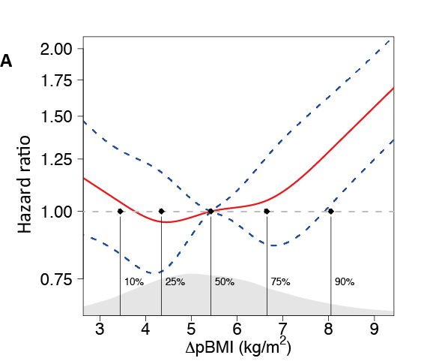

Figure 1b

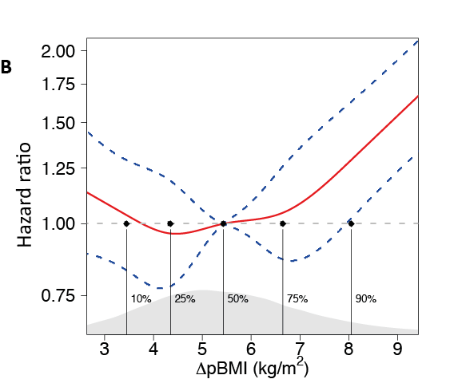

Figure 2
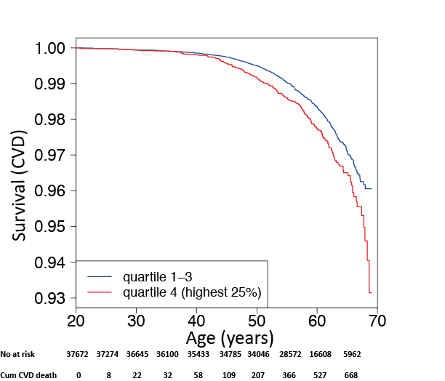

Supplementary Appendix

“Association between excessive BMI increase during puberty and risk of adult cardiovascular mortality in men: a population-based cohort study”

Prof Claes Ohlsson¹, Maria Bygdell PharmD¹, Arvid Sondén MSc², Prof Annika Rosengren³, Jenny M Kindblom PhD¹

Supplementary Methods
Study Population
For almost 100 years, the general health and wellbeing of Swedish children has been followed by school health care (SHC) from school start (at age 7 for the study cohort) throughout the school years. The SHC program includes vaccinations and direct measurements of height and weight performed by specially trained school nurses. From the early 1950s (coinciding with childhood measurements from ≈ birth year 1943), 98·5% of all pupils nationwide were covered by SHC (1). The subjects had on average 1·9 measurements in the childhood BMI period and 1·3 measurements in the young adult BMI period. Information on country of birth and migration was retrieved from the Longitudinal Integration Database for Health Insurance and Labor Market Studies held at Statistics Sweden. Country of birth was categorized as Sweden (the study subject and both his parents born in Sweden) or not Sweden (the subject, or one or both parents not born in Sweden or information on country of birth is missing).

Exposures
Age adjustments of pre-pubertal childhood BMI (at age 8) and young adult BMI (at age 20) were performed separately using linear regression with BMI as dependent variable and age as independent variable using all available BMI measurements in the age intervals. The age intervals were 6.5- 9.5 years of age for pre-pubertal childhood BMI and 17.5-22 years of age for young adult BMI, respectively. The age-dependent change was assumed to follow the slope of the fitted models and BMI at eight / twenty years of age was estimated using the slope of the fitted model. Thus, the BMI values were interpolated on the population level.
Onset and duration of puberty varies between individuals, and pubertal development greatly alters body composition (2). To avoid the confounding effect of ongoing puberty on BMI, we defined the pubertal period with a rather wide time window. Therefore, the time between 8 and 20 years included not only the complete pubertal period but also periods of varying length both before and after puberty. The BMI change during puberty was therefore defined as the difference between BMI at 20 years of age and BMI at 8 years of age.

Outcomes
Dates and diagnoses for all deaths were retrieved from the Cause of Death Register with information on causes of deaths since 1961, covering the entire follow-up period in the present study. The causes of death were coded according to the International Classification of Diseases (ICD) system. CVD mortality was defined as I00-I99 in ICD10, and as 390-459 in ICD 8 and 9. Accuracy of classification of causes of death in the Swedish register is reported to be high (3, 4). For the analyses on separate CVD diagnoses as underlying causes of death, the following definitions were used: Coronary Heart Disease (CHD) I20-25 (ICD10) and 410-414 (ICD8 and 9); Stroke I61, I63, I64 (ICD10) and 431, 433, 434, 436 (ICD8 and 9); Ischemic Stroke (IS) I63 (ICD10) and 433, 434 (ICD8 and 9); Intracerebral Hemorrhage (ICH) I61 (ICD10) and 431 (ICD8 and 9).

Cohort representativeness
Sweden has had a compulsory school attendance since 1936, starting from the year the child turned 7. From the early 1950s, 98.5% of all children were followed by school health care (1). Due to missing data and missing Personal Identity Number, not all children with a school health record are included in the present study (24·7 % not included; Figure S1). In order to investigate if those included in the study and those not included differ with regard to young adult BMI, we evaluated BMI from the examination at conscription. Young adult BMI at conscription was similar for the two groups (BMI mean [SD]; Included subjects 21·13 [2·53] kg/m²; Not included subjects 21·15 [2·57]; non-significant using t-test), suggesting that the cohort is representative for Gothenburg, the second largest city in Sweden.

Statistical Analyses
There were no missing values for the main parameters (childhood BMI, BMI change during puberty, young adult BMI, country of birth, birth year or follow-up). The only parameter without a complete set of data was birthweight (n=35,662 which corresponds to 95% of the entire cohort). Models including birthweight only included the subgroup of boys with birthweight available. The assumption of proportionality in the Cox regression models was assessed both through visual evaluations of Schoenfeld residual plots, and through proportional hazard tests using the “survival” package in the R statistical software (5-7).
Childhood BMI was standardized within the study population, having zero mean and unit variance. The standard score (Z) was calculated as Z=(x-μ)/σ. μ is the mean of the study population and σ is the standard deviation of the study population.
Cumulative incidence plots (Figure S3) were performed for both CVD mortality and non-CVD mortality according to if subjects had a BMI change during puberty above (quartile 4) or below (quartiles 1-3) a threshold of 6·7 BMI units.

Supplementary Tables

Table S1 The risk for cardiovascular mortality according to CDC (Centers for Disease Control and Prevention) percentiles of childhood BMI.
Childhood BMI percentile | <25th  (n=9,485) | 25th to 50th  (n=11,932) | 50th to 75th  (n=11,067) | 75th to 85th  (n=2830) | >85th  (n=2358)
Cardiovascular mortality (HR (95% CI)) | 1·00(0·82-1·21) | 1 (reference) | 0·94(0·78-1·14) | 1·28(0·97-1·68) | 1·27(0·94-1·71)

Hazard Ratios (HRs) for CVD mortality were calculated using Cox proportional hazards regression. Birth year and country of birth were included as covariates. Corresponding absolute childhood BMI at 8 years of age for 25th percentile= 14·8 kg/m², 50th percentile= 15·8 kg/m², 75th percentile= 17·0 kg/m², 85th percentile= 17·9 kg/m² according to the CDC reference (1). HR= Hazard Ratio, CI= Confidence Intervals, BMI= Body Mass Index.

Table S2 Cardiovascular Disease mortality according to overweight or obesity at 8 years of age (childhood) and/or at 20 years of age (young adult age) in 37,672 Swedish men followed for a mean of 37·8 years after age 20.
 | Childhood/Young adult BMI status | Fatal CVD events | HR (95% CI)
A | CVD mortality after 20 years of age
 | Normal weight/Normal weight (n=33,514) | 591 | 1 (reference)
 | Overweight/Normal weight (n=1,177) | 17 | 0·84(0·52-1·36)
 | Normal weight/Overweight (n=1,690) | 57 | 2·19(1·67-2·88)
 | Overweight/Overweight (n=568) | 17 | 1·79(1·11-2·90)
B | CVD mortality after 20 years of age
 | Normal weight/Normal weight (n=33,514) | 591 | 1 (reference)
 | Obese/Normal weight (n=191) | 6 | 1·97(0·88-4·41)
 | Normal weight/Obese (n=110) | 9 | 5·83(3·02-11·28)
 | Obese/Obese (n=109) | 9 | 5·47(2·83-10·57)

Hazard Ratios (HRs) for CVD mortality were calculated using Cox proportional hazards regression. In table 3 of the article, overweight and obese subjects were pooled into one group referred to as overweight. In this table the data is presented separately for overweight (A) and obese (B) subjects. Childhood overweight at 8 years of age was defined as BMI ≥17·9 kg/m² and < 20·0 kg/m². Childhood obesity was defined as BMI ≥20·0 kg/m² (17). Young adult overweight at 20 years of age was defined as BMI ≥25 kg/m² and <30·0 kg/m². Young adult obesity was defined as BMI ≥30·0 kg/m². Data are adjusted for birth year and country of birth. CI= Confidence Interval.
Panel A: Normal weight/Normal weight = Not overweight or obese at 8 or 20 years of age, Overweight/Normal weight = Overweight at 8 but not at 20 years of age, Normal weight/Overweight = Overweight at 20 but not at 8 years of age, Overweight/Overweight = Overweight both at 8 and 20 years of age.
Panel B: Normal weight/Normal weight = Not overweight or obese at 8 or 20 years of age, Obese/Normal weight = Obese at 8 but not at 20 years of age, Normal weight/Obese = Obese at 20 but not at 8 years of age, Obese/obese = Obese both at 8 and 20 years of age.

Table S3 Adjusted Hazard Ratios for disease-specific CVD mortality in relation to childhood BMI and BMI change during puberty in 37,672 Swedish men followed for a mean of 37·8 years after age 20.
 | Separate analyses |  | Combined analysis
 | Childhood BMI  HR (95% CI)  per SD increase | ΔpBMI  HR (95% CI)  per SD increase | Childhood BMI  HR (95% CI)  per SD increase | ΔpBMI  HR (95% CI)  per SD increase
CHD mortality | 1·15(1·04-1·26) | 1·27(1·16-1·38) | 1·12(1·02-1·24) | 1·25(1·14-1·36)
Stroke mortality | 0·97(0·77-1·22) | 1·35(1·11-1·63) | 0·93(0·74-1·18) | 1·36(1·12-1·65)
IS mortality | 0·92(0·60-1·40) | 1·30(0·91-1·86) | 0·89(0·58-1·37) | 1·32(0·92-1·90)
ICH mortality | 1·00(0·74-1·34) | 1·41(1·12-1·78) | 0·95(0·70-1·28) | 1·42(1·12-1·81)
Hazard Ratios (HRs) were calculated using Cox proportional hazards regression. ΔpBMI = BMI change during puberty. CI= Confidence Interval, CHD= Coronary Heart Disease, IS= Ischemic Stroke, ICH= Intra Cerebral Hemorrage, SD= Standard Deviation. N=37,672. In the separate analyses, childhood BMI or ΔpBMI was included and adjustment was done for birth year and country of birth. The combined analyses included both childhood BMI and ΔpBMI and were adjusted for birth year and country of birth. CHD deaths n=381, Stroke deaths n=75, IS deaths n=23, ICH deaths n=46.

Table S4 Adjusted Hazard Ratios for mortality in relation to young adult BMI in 37,672 Swedish men followed for a mean of 37·8 years after age 20.
Young adult BMI
HR (95% CI)
per SD increase
All-cause mortality | 1·04(1·00-1·07)
CVD mortality | 1·22(1·13-1·30)
Hazard Ratios (HRs) were calculated using Cox proportional hazards regression. aBMI = young adult BMI at 20 years of age. CI= Confidence Interval, CVD= Cardiovascular Disease, SD= Standard Deviation. N=37,672. The analyses were adjusted for birth year and country of birth.

Table S5
Adjusted Hazard Ratios for mortality in combined models including both BMI change during puberty and young adult BMI in 37,672 Swedish men followed for a mean of 37·8 years after age 20.
 | ΔpBMI  HR (95% CI)  per SD increase | aBMI  HR (95% CI)  per SD increase
All-cause mortality | 1·06(1·00-1·13) | 0·99(0·93-1·05)
CVD mortality | 1·14(1·00-1·29) | 1·09(0·95-1·24)
Hazard Ratios (HRs) were calculated using Cox proportional hazards regression. ΔpBMI = BMI change during puberty, aBMI= young adult BMI at 20 years of age, CI= Confidence Interval, CVD= Cardiovascular Disease, SD= Standard Deviation. N=37,672. These combined analyses included both ΔpBMI and aBMI and were adjusted for birth year and country of birth. p<0·05 for ΔpBMI for both all-cause mortality and CVD mortality.

Table S6 Adjusted Hazard Ratios for mortality in relation to childhood BMI and BMI change during puberty, excluding deaths or censoring occurring before age 30.
 | Separate analyses |  | Combined analysis
 | Childhood BMI  HR (95% CI)  per SD increase | ΔpBMI  HR (95% CI)  per SD increase | Childhood BMI  HR (95% CI)  per SD increase | ΔpBMI  HR (95% CI)  per SD increase
All-cause mortality | 1·02(0·98-1·06) | 1·06(1·02-1·10) | 1·02(0·98-1·06) | 1·05(1·02-1·09)
CVD mortality | 1·11(1·03-1·19) | 1·23(1·15-1·32) | 1·09(1·01-1·17) | 1·22(1·14-1·30)
Hazard Ratios (HRs) were calculated using Cox proportional hazards regression. ΔpBMI = BMI change during puberty. CI= Confidence Interval, CVD= Cardiovascular Disease. In the separate analyses, childhood BMI or ΔpBMI was included and adjustment was done for birth year and country of birth. The combined analyses included both childhood BMI and ΔpBMI and adjustment was done for birth year and country of birth. n=36,645, CVD death = 688.

Table S7 Adjusted Hazard Ratios for mortality in relation to childhood BMI and BMI change during puberty, excluding deaths or censoring occurring before age 40.
 | Separate analyses |  | Combined analysis
 | Childhood BMI  HR (95% CI)  per SD increase | ΔpBMI  HR (95% CI)  per SD increase | Childhood BMI  HR (95% CI)  per SD increase | ΔpBMI  HR (95% CI)  per SD increase
All-cause mortality | 1·04(1·00-1·08) | 1·07(1·03-1·11) | 1·03(0·99-1·08) | 1·07(1·03-1·11)
CVD mortality | 1·12(1·04-1·20) | 1·24(1·15-1·33) | 1·10(1·02-1·18) | 1·22(1·14-1·31)
Hazard Ratios (HRs) were calculated using Cox proportional hazards regression. ΔpBMI = BMI change during puberty. CI= Confidence Interval, CVD= Cardiovascular Disease. In the separate analyses, childhood BMI or ΔpBMI was included and adjustment was done for birth year and country of birth. The combined analyses included both childhood BMI and ΔpBMI and adjustment was done for birth year and country of birth. n=35,433, CVD death =652.

Table S8 Adjusted Hazard Ratios for mortality in relation to childhood BMI and BMI change during puberty, excluding deaths or censoring occurring before age 50.
 | Separate analyses |  | Combined analysis
 | Childhood BMI  HR (95% CI)  per SD increase | ΔpBMI  HR (95% CI)  per SD increase | Childhood BMI  HR (95% CI)  per SD increase | ΔpBMI  HR (95% CI)  per SD increase
All-cause mortality | 1·05(1·01-1·11) | 1·07(1·02-1·12) | 1·05(1·00-1·10) | 1·07(1·02-1·12)
CVD mortality | 1·09(1·00-1·19) | 1·17(1·08-1·27) | 1·07(0·99-1·17) | 1·16(1·07-1·26)
Hazard Ratios (HRs) were calculated using Cox proportional hazards regression. ΔpBMI = BMI change during puberty. CI= Confidence Interval, CVD= Cardiovascular Disease. In the separate analyses, childhood BMI or ΔpBMI was included and adjustment was done for birth year and country of birth. The combined analyses included both childhood BMI and ΔpBMI and adjustment was done for birth year and country of birth. n=34,046 CVD death =503.

Table S9 Cardiovascular Disease mortality according to BMI change during puberty grouped by different follow-up periods.
 | Person-years FU | CVD death | HR (95% CI)
10 years FU (= age 30) | 372,293 | 22 | 0·90(0·58-1·40)
20 years FU (= age 40) | 733,063 | 58 | 1·04(0·81-1·34)
30 years FU (= age 50) | 1,080,649 | 207 | 1·33(1·19-1·49)
40 years FU (= age 60) | 1,355,406 | 527 | 1·25(1·16-1·34)
Complete FU (49 years = age 69) | 1,422,185 | 710 | 1·22(1·14-1·31)

ΔpBMI= BMI change during puberty. Hazard Ratios (HRs) were calculated using Cox proportional hazards regression and are given as SD increase in ΔpBMI. CI= Confidence Interval, FU = follow-up. CVD= Cardiovascular Disease. Adjustment was done for birth year and country of birth.

Table S10 Cardiovascular Disease mortality according to overweight at 8 years of age (childhood) and/or at 20 years of age (young adult age) grouped by different follow-up periods.
Childhood/Adult BMI status | 10 years FU  (= Age 30) | 20 years FU  (= Age 40) | 30 years FU  (=Age 50) | 40 years FU  (= Age 60) | Complete FU Period (49 years; = Age 69)
 | HR (95% CI) | HR (95% CI) | HR (95% CI) | HR (95% CI) | HR (95% CI)
Normal weight/Normal weight (n=33,514) | 1 (referent) | 1 (referent) | 1 (referent) | 1 (referent) | 1 (referent)
Overweight/Normal weight (n=1,368) | NA | NA | 0·74(0·30-1·80) | 0·93(0·56-1·53) | 0·99(0·65-1·50)
Normal weight/Overweight (n=1,800) | NA | 0·34(0·05-2·48) | 2·98(1·95-4·54) | 2·81(2·14-3·69) | 2·39(1·86-3·09)
Overweight/Overweight (n=990) | 1·56(0·21-11·61) | 1·19(0·29-4·90) | 2·05(1·08-3·88) | 1·89(1·24-2·88) | 1·85(1·28-2·67)

Hazard Ratios (HRs) for CVD mortality were calculated using Cox proportional hazards regression. Normal weight/Normal weight = Not overweight at 8 or 20 years of age (n=33,514); Overweight/Normal weight = Overweight at 8 but not at 20 years of age (n=1,368); Normal weight/Overweight = Overweight at 20 but not at 8 years of age (n=1,800); Overweight/Overweight = Overweight both at 8 and 20 years of age (n=990). Childhood overweight at 8 years of age was defined as BMI ≥17·9 kg/m² (1) while young adult overweight at 20 years of age was defined as BMI ≥25 kg/m². Data are adjusted for birth year and country of birth. CI= Confidence Interval. NA = No HR available from this model due to the low number of deaths evaluated. FU = follow-up.

Table S11 Adjusted Hazard Ratios for mortality in relation to childhood BMI and BMI change during puberty excluding boys who had country of birth for the subjects and/or their parents categorized as other than Sweden.
 | Separate analyses |  | Combined analysis
 | Childhood BMI  HR (95% CI)  per SD increase | ΔpBMI  HR (95% CI)  per SD increase | Childhood BMI  HR (95% CI)  per SD increase | ΔpBMI  HR (95% CI)  per SD increase
All-cause mortality | 1·01(0·97-1·06) | 1·07(1·02-1·11) | 1·01(0·97-1·05) | 1·07(1·02-1·11)
CVD mortality | 1·09(1·01-1·19) | 1·21(1·12-1·31) | 1·08(0·99-1·17) | 1·20(1·11-1·29)

Hazard Ratios (HRs) were calculated using Cox proportional hazards regression. ΔpBMI= BMI change during puberty. CI= Confidence Interval, CVD= Cardiovascular Disease. N=31,407, CVD death = 551. In the separate analyses, childhood BMI or ΔpBMI was included and adjustment was done for birth year. The combined analyses included both childhood BMI and ΔpBMI and adjustment was done for birth year.

Table S12 Cardiovascular Disease mortality according to overweight at 8 years of age (childhood) and/or at 20 years of age (young adult age) excluding boys who had country of birth for the subjects and/or their parents categorized as other than Sweden.
Childhood/Young adult BMI status | HR (95% CI)
Normal weight/Normal weight (n=27,979) | 1 (referent)
Overweight/Normal weight (n=1,138) | 1·06(0·67-1·68)
Normal weight/Overweight (n=1,469) | 2·59(1·95-3·42)
Overweight/Overweight (n=821) | 1·75(1·13-2·71)

Hazard Ratios (HRs) for CVD mortality were calculated using Cox proportional hazards regression. Normal weight/Normal weight = Not overweight at 8 or 20 years of age, Overweight/Normal weight = Overweight at 8 but not at 20 years of age, Normal weight/Overweight = Overweight at 20 but not at 8 years of age, Overweight/Overweight = Overweight both at 8 and 20 years of age. Childhood overweight at 8 years of age was defined as BMI ≥17·9 kg/m² (1) while young adult overweight at 20 years of age was defined as BMI ≥25 kg/m². Data are adjusted for birth year. CI= Confidence Interval.

Legends to Supplementary Figures

Figure S1 Flow chart of included individuals. N= 37,672 Swedish men followed for a mean of 37·8 years. PIN= personal identification number, BMI= body mass index.

Figure S2 Smoothed plots of hazard ratios (HRs) for all-cause mortality according to BMI change during puberty in 37,672 Swedish men followed for a mean of 37·8 years after age 20.
Cox regression analysis using a restricted cubic spline-approach for a flexible non-linear assessment of the hazard ratio (HR) for all-cause mortality after 20 years of age in relation to BMI change during puberty (ΔpBMI; p<0·0001). Five knots were placed at the ΔpBMI percentiles 10, 25, 50, 75 and 90 (indicated by vertical black lines). The model was adjusted for birth year and country of birth. Data is presented as hazard ratio (red line) ± the 95% confidence interval (blue dotted line). The distribution of subjects according to ΔpBMI is shown in gray in the lower part of the figure. The horizontal dashed line corresponds to the reference (median ΔpBMI= 5·44 kg/m²) HR of 1·0 (no excess rate of events).

Figure S3 Cumulative incidence plots for cardiovascular mortality (A) and non-cardiovascular mortality (B). Mortality is shown according to if subjects had a BMI change during puberty in quartile 4 (Q4, red) or Q1-3 (black). Cumulative incidence in each group is shown as the number of deaths at a given time point divided by the number of included subjects in that group. Shaded area represents 95% confidence interval.

Figure S4 Smoothed plots of hazard ratios (HRs) for CVD mortality according to childhood BMI (A) and young adult BMI (B) in 37,672 Swedish men followed for a mean of 37·8 years after age 20.

Cox regression analysis using a restricted cubic spline-approach for a flexible non-linear assessment of the hazard ratio (HR) for CVD mortality after 20 years of age in relation to childhood BMI (non-significant) (A) or young adult BMI (p=0·0017) (B). Five knots were placed at percentiles 10, 25, 50, 75 and 90 (Indicated by vertical black lines). Both models were adjusted for birth year and country of birth. Data is presented as hazard ratio (red line) ± the 95% confidence interval (blue dotted line). The distributions of subjects according to childhood BMI (A) or young adult BMI (B) are shown in gray in the lower part of the figures. The horizontal dashed line corresponds to the reference (median) HR of 1·0 (no excess rate of events).

Figure S5 Unadjusted Kaplan-Meier curves of CVD death free survival according to childhood BMI (A) and young adult BMI (B) in 37,672 Swedish men followed for a mean of 37·8 years after age 20.
The graphs show the rates of adult CVD death according to if subjects had a childhood BMI (A) or young adult BMI (B) in quartile 4 compared with quartiles 1-3. The p values for comparison between the two groups assessed by log-rank test were p=non-significant for childhood BMI and p= 0·0007 for young adult BMI. CVD= cardiovascular disease.

Figure S6 Smoothed plots of hazard ratios (HRs) for CVD mortality according to BMI change during puberty adjusted for young adult BMI in 37,672 Swedish men followed for a mean of 37·8 years after age 20.
Cox regression analysis using a restricted cubic spline-approach for a flexible non-linear assessment of the hazard ratio (HR) for CVD mortality after 20 years of age in relation to BMI change during puberty (ΔpBMI) adjusted for young adult BMI (p<0·0001). Five knots were placed at the ΔpBMI percentiles 10, 25, 50, 75 and 90 (indicated by vertical black lines). The model was adjusted for birth year and country of birth. Data is presented as hazard ratio (red line) ± the 95% confidence interval (blue dotted line). The distribution of subjects according to ΔpBMI is shown in gray in the lower part of the figure. The horizontal dashed line corresponds to the reference (median ΔpBMI= 5·44 kg/m2) HR of 1·0 (no excess rate of events).

Reference
1. Herlitz CW. Skolhälsovårdens historia. Bergvalls, Stockholm; 1961.
2. Loomba-Albrecht LA, Styne DM. Effect of puberty on body composition. Curr Opin Endocrinol Diabetes Obes. 2009;16(1):10-5.
3. Michaelsson K, Wolk A, Langenskiold S, Basu S, Warensjo Lemming E, Melhus H, et al. Milk intake and risk of mortality and fractures in women and men: cohort studies. BMJ (Clinical research ed). 2014;349:g6015.
4. Tunstall-Pedoe H, Kuulasmaa K, Amouyel P, Arveiler D, Rajakangas AM, Pajak A. Myocardial infarction and coronary deaths in the World Health Organization MONICA Project. Registration procedures, event rates, and case-fatality rates in 38 populations from 21 countries in four continents. Circulation. 1994;90(1):583-612.
5. R Core Team: R: A language and environment for statistical computing. R Foundation for Statistical Computing, Vienna, Austria, 2015. URL https://www.R-project.org/.
6. Therneau T: A Package for Survival Analysis in S. version 2.38, 2015. http://CRAN.R-project.org/package=survival.
7. Frank E Harrell Jr: rms: Regression Modeling Strategies. R package version 4.4-2, 2016. https://CRAN.R-project.org/package=rms.

Supplementary Figures
Supplementary Figure 1
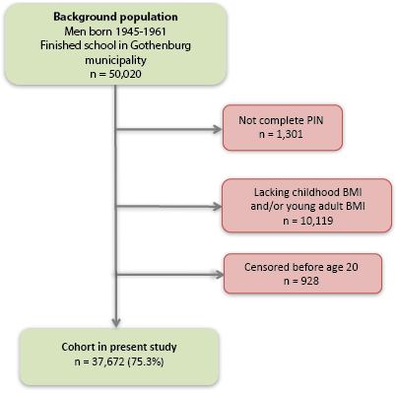

Supplementary Figure 2
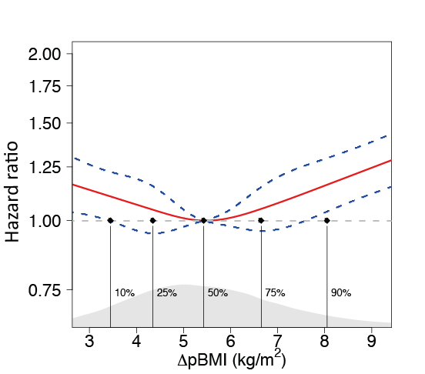

Supplementary Figure 3A
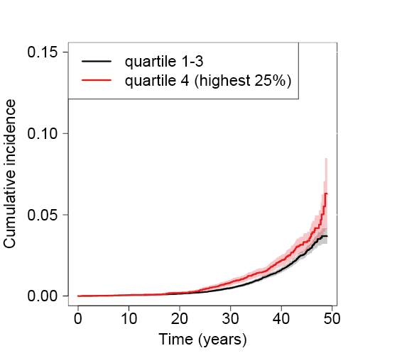

Supplementary Figure 3B
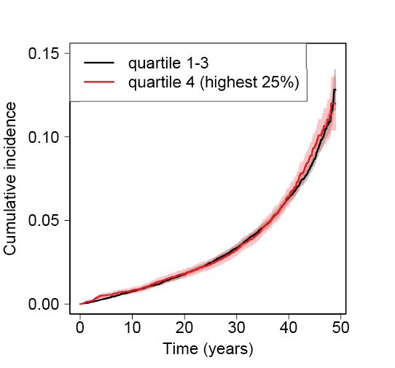

Supplementary Figure 4A
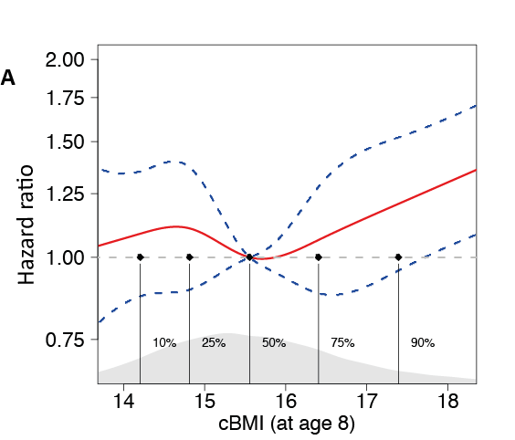

Supplementary Figure 4B
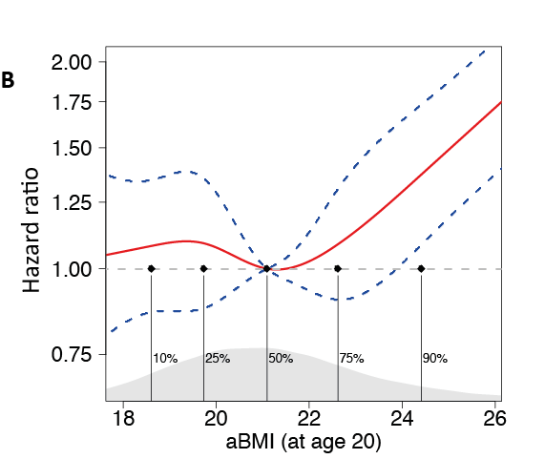

Supplementary Figure 5A
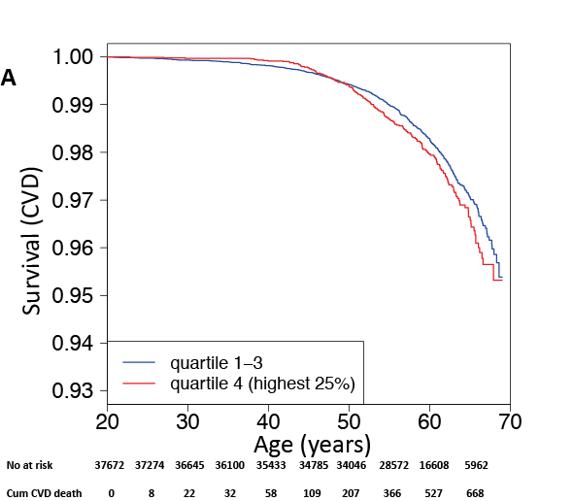

Supplementary Figure 5B
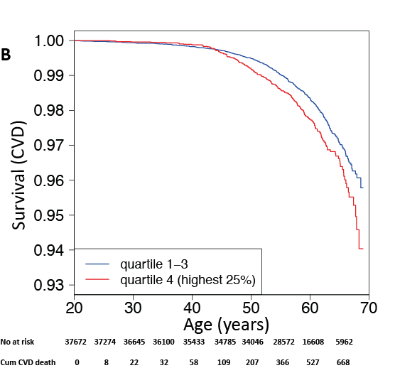

Supplementary Figure 6
